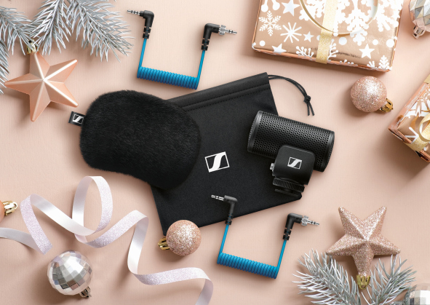 | 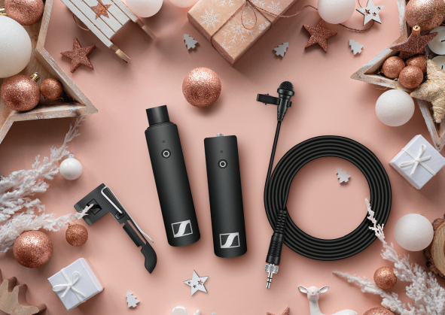

Delight the filmmaker in your life with the gift of outstanding audio

Marlow/UK, 27 October 2020 – Can’t see what to buy for the filmmaker in your life? Forget 8K and 4K, or gizmos and gimbals, with even consumer cameras offering exceptional high-quality video, it’s what we hear that adds a professional gloss of realism and impact to video content. No matter if they’re taking their first steps in vlogging or bringing broadcast-quality footage to a global audience, this holiday season, audio specialist Sennheiser will help you give the filmmaker in your life the magic of sparkling audio.

Be heard with simply superior sound
MKE 200
Quality video is easy to come by these days, but that isn’t always the case when it comes to quality audio. Even the phone in your pocket has the ability to shoot video in crisp 4K resolution, so why shouldn’t it sound as good as it looks? This is where an external microphone such as Sennheiser’s new MKE 200 microphone comes in.

Rugged and sleek enough for DSLRs, DSLMs or phones – the MKE 200 from Sennheiser is an ideal take-anywhere audio upgrade

- Rugged and sleek enough for DSLRs, DSLMs, or phones – the ideal take-anywhere audio upgrade
- Directional mic brings presence to your voice – perfect for stepping up your vlogging game
- Built-in wind screen and integrated shock mount – Your recordings will sound cleaner than ever before
- Comes complete with furry windshield, TRS cable for cameras and TRRS cable for smartphones, plus storage bag

Natural stereo sound
MKE 440
Sennheiser’s MKE 440 stereo camera microphone delivers picture-perfect stereo sound – it captures sound from the subject with clarity while still retaining a pleasant level of ambient sound for atmosphere. With two matched shotgun microphones in a V-shaped configuration, it acoustically covers a stereo width equivalent to a 35mm camera lens – so you can hear what you see – without distractions from off-axis sounds.

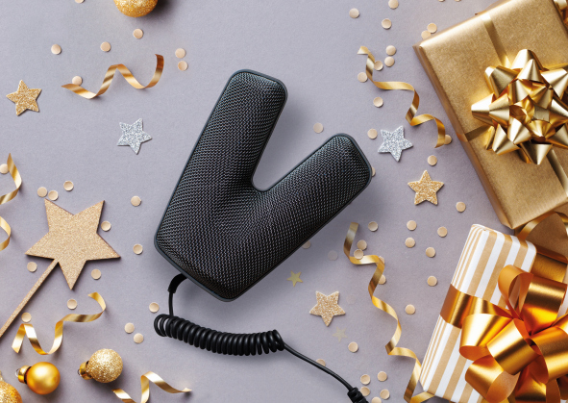 | With its dual mini shotgun mics, the Sennheiser MKE 440 delivers picture-perfect, natural stereo sound

- Homogeneous stereo image of the entire field with particularly high speech intelligibility in the focal point of the image frame
- Remarkable dynamic range lets you capture everything from quiet whispers to loud rock music
- Dual mini-shotgun mics create frontal focus while allowing a subtle level of ambient and background noise for a sense of location

Take a longer view
MKE 600 shotgun mic
When shooting wider shots or using longer focal lengths, you often need the creative freedom to place the camera further away from the subject. This is where Sennheiser’s MKE 600 shotgun microphone excels: its distinct (super-cardioid/lobar) pick-up pattern ensures outstanding performance even in demanding filming situations and maximum possible attenuation of unwanted noise elements from the side. As a versatile tool ready for virtually any professional challenge, you can combine the MKE 600 with either an XLR or a mini-jack cable (please order separately). A hairy cover is available too when filming outdoors.

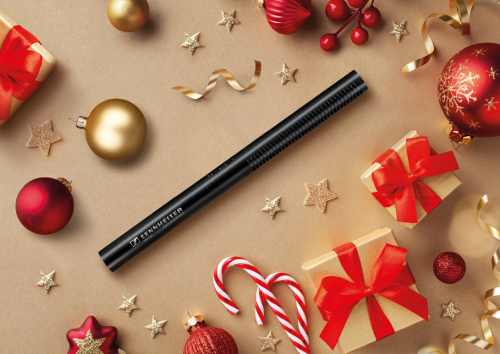 | The MKE 600 delivers outstanding performance even in demanding filming situations, with a super-cardioid pick-up pattern that offers maximum attenuation of unwanted noise from the sides

- Catches sound with pin-point accuracy even in acoustically unfavorable environments
- Switchable high-pass filter reduces structure-borne noise and wind noise
- Can use phantom or battery power
- Matching foam windshield and a shock mount that fits onto the camera shoe mount are included, with camera cable and hairy cover available separately

Give the freedom of wireless audio
XSW-D Portable Lavalier Set
Wireless means never missing the moment. Videographers and mobile journalists seeking to effortlessly capture dialog will love Sennheiser’s groundbreaking XS Wireless Digital Portable Lavalier Set, which brings great wireless audio within reach. Compatible with any DSLR or DSLM, XSW-D defines the term “plug-n-play” – the receiver connects to your camera with a 3.5 mm cable and links wirelessly to the included transmitter and ME 2-II lavalier mic. If you’re looking to enhance your interview workflow with clean and consistent audio, this set lets you do so without the burden of a complex setup.

Videographers and mobile journalists seeking to effortlessly capture dialog will love Sennheiser’s groundbreaking XS Wireless Digital Portable Lavalier Set

- The freedom of a wireless with effortlessly intuitive single button operation
- Uses 2.4 GHz frequency for fuss-free and license-free operation worldwide
- 75 m range (250 ft) in optimal conditions
- XSW-D Portable Lavalier Set includes an ME 2-II clip-on microphone, an XSW-D transmitter, an XSW-D receiver for the camera, a cold shoe mount, 3.5 mm coiled cable, belt clip and a USB-A to USB-C charging cable

(Ends)

Price information:
MKE 200: EUR 99 (MSRP) / USD 99.95 (MAP)
MKE 440: EUR 349 (MSRP) / USD 349.95 (MAP)
MKE 600: EUR 299 (MSRP) / USD 329.95 (MAP)
XSW-D Portable Lavalier Set: EUR 299 (MSRP) / USD 299.95 (MAP)

The images accompanying this press release plus additional product photos can be downloaded at https://sennheiser-brandzone.com/c/181/cgbiCqCv.

About Sennheiser
Founded in 1945, Sennheiser is celebrating its 75th anniversary this year. Shaping the future of audio and creating unique sound experiences for customers – this aim unites Sennheiser employees and partners worldwide. The independent family company, which is managed in the third generation by Dr. Andreas Sennheiser and Daniel Sennheiser, is today one of the world’s leading manufacturers of headphones, loudspeakers, microphones and wireless transmission systems. In 2019, the Sennheiser Group generated turnover totaling €756.7 million. www.sennheiser.com

Global Press Contact

Stephanie Schmidt
Stephanie.schmidt@sennheiser.com
+49 (5130) 600 – 1275

